The Inequality of Self-Efficacy

for Junior College and Traditional University Students

Abstract

Higher education research highlights the difficulties students face when transitioning from a junior college to a traditional university. This study explored a gap between junior vs. traditional university students’ academic self-efficacy beliefs. This study also controlled for the effects of the student role-identity and academic performance on academic self-efficacy. Results found that junior college students experienced lower academic self-efficacy beliefs despite having higher overall grade point averages. Additionally, junior college students reported that their student role-identity was less important to them compared to students at the large public university. Findings suggest that structural disadvantage at the institutional level of higher education reproduces inequalities found in society at large.
Keywords: Higher Education, Inequality, Self-Efficacy, Junior College, Traditional University

The Inequality of Self-Efficacy

for Junior College and Traditional University Students

Research finds that students from lower socio-economic status (SES) are disproportionally represented on junior college campuses (cf. Cohen & Brawer, 2003); these students have a difficult time transiting from a junior college setting to a traditional university setting (Alicia, John, & Tatiana, 2008; Townsend, McNearny, & Arnold, 1993). An overlooked element of the gap between junior college students and wealthier peers attending traditional university is social psychological inequality, in particular differences in self-efficacy beliefs sustained at the institutional level of higher education (Aronson, Blanton, & Cooper, 1995).
This paper explores differences in self-efficacy beliefs between junior college and traditional university students, testing for structural inequality at the institutional level of higher education (Royce, 2009). The central research question asks if the junior college experience helps students by equalizing their self-efficacy beliefs, relative to their university peers.
Self-efficacy is defined as a person’s belief about causal ability, in other words the ability to exercise control over self and environment (Gecas, 1989). Self-efficacy beliefs develop during childhood. However, self-efficacy beliefs are not static and continue to be adapted across multiple dimensions of the life-course (Bandura, 2001); and because a person’s self-efficacy beliefs are subject to change they are an ongoing mechanism of behavior (Britner & Pajares, 2006).
An important factor influencing access to and success in higher education is a self-selection process involving self-efficacy beliefs, called “matching” (Bandura et al., 2001; Choi, 2005). There are two parts of this self-efficacy belief. First, students’ beliefs about their particular ability to be successful in a given program; and second, students’ beliefs about institutional restraint or empowerment (Putwain, Sander, & Larkin, 2012). The sum of this self-efficacy belief is central to the decision to attend (see Reay, David, & Ball, 2005) and remain in a higher education program (Mattern & Shaw, 2010).
Matching also includes a filtering process based on “social class and ethnic differences” (Ball, Davies, David, & Reay, 2002, p. 58). Students from disadvantaged backgrounds attending higher education programs often start college with a diminished sense of personal efficacy, irrespective of past performance (Eagan, Monica, & Sylvia, 2011). Pajares (1996) notes that diminished self-efficacy beliefs can overpower past performance in determining future performance (see also Caprara et al., 2011):
“Students with similar previous performance attainments and cognitive skills may differ in subsequent performance as a result of differing self-efficacy perceptions because these perceptions mediate between prior attainments and academic performances” (p. 554).
Bandura (1986) links self-efficacy beliefs to behavior by pointing out that people think about the implications and possibilities of their actions, guiding their behavior using this forethought. Bandura’s emphasis on anticipation takes root in the different roles (e.g., student, employee, and friend) people occupy. Roles get defined by expectations, locating people within the immediate social structure (Turner, 1978). People consider their actions using these expectations, anticipating their ability to be a causal agent in a given role. For instance, the role of “student” gets defined by a position within the academic realm and students interact with a wide variety of others (e.g., peers, teachers, administration). Interaction with an instructor carries a set of expectations differing from expectations for interacting with peers. The point is, a student’s agentive ability (actual and imagined) changes based on the anticipated expectations of the student role within the environment defining the role (see also Ajzen, 1991).
Self-efficacy beliefs link directly to role-positions through the identities that are associated with the role. As people become more or less committed to a given role, a self-meaning known as an identity develops based on the role (Stryker & Serpe, 1994). Consider the example of a person with a student role and a recreational role, for instance an amateur competitive athlete. Within the student role, the person may have low self-efficacy beliefs as a “student” and yet as an athlete possesses high self-efficacy beliefs. What accounts for the difference? Part of the answer comes from the student engaging in the anticipatory process Bandura mentions, “As a student do my actions have power?” As the student considers their ability to be agentive they learn that their actions lack power, however, when this person considers their ability relative to other athletes their actions have power (both anticipatorily and behaviorally).
Another important piece of the answer comes from the importance of the student-role versus athlete-role within the individual’s self-concept. Distinct role-identities have varying importance (see Morris, 2012; 2013); and, role-identities with greater self-efficacy tend to be more central to the self-concept (Gecas & Schwalbe, 1983). As centrality increases the identity increasingly defines who the person is and how they will behave (Stryker & Serpe, 1994).
Self-efficacy is a mixture between internalized beliefs about agentive ability related to a particular identity and the social structural expectations that shape those beliefs (Bandura, 1986). In this view, self-efficacy is not purely an internal psychological process. The student role-identity is defined by role expectations that are sustained within a given academic environment and academic environments differ in their ability to empower students. Therefore, academic self-efficacy beliefs are a product of anticipation related to the student role-identity within a specific academic setting.
This paper focuses on academic self-efficacy at two different settings of higher education. Academic Self-Efficacy (AE) is defined as a student’s perception of empowerment to accomplish the things they want to do, as sustained by the institution they are attending (see Majer, 2009 for a test of self-efficacy in the community college setting). This paper also considers how the student role-identity correlates with feelings of empowerment, and how academic performance, SES, as well as global self-efficacy beliefs predict domain specific AE.
A principal goal of junior college programs is to transfer students to baccalaureate granting institutions, thus ostensibly providing students with greater life opportunities (van Dinther, Dochy, & Segers, 2011). If self-efficacy beliefs “mediate between prior attainments and [current] academic performances,” do junior college programs bridge the gap by providing students with self-efficacy beliefs that are relatively comparable to those held by traditional university students? Based on the intersecting variables discussed the following hypotheses are proposed:
Hypotheses
H1: As SES increases the likelihood of attendance at the traditional university will increase.

H2: Students attending the traditional university will have higher global self-efficacy beliefs.

H3: Students attending the junior college will have lower academic self-efficacy beliefs.

H4: Based on the full-time nature of a traditional university, the student role-identity will be more central for traditional university students.

Methods
Data came from two sample populations; students at a large public university and students at a nearby junior college. Both campuses are located in the same Midwestern city in the United States. This study used a double-blind anonymous design with electronic response pads (clickers) in the classroom setting. A total N of 1,062 students (470 men, 559women) participated in surveys; 562 from the junior college and 500 students in 100 and 200 level courses at the traditional university. The demographic makeup of each institution was successfully recreated through the sampling procedure.
Analysis proceeded in five stages. The first stage was Exploratory Data Analysis (EDA) where data were checked for distribution properties. Following EDA, the second and third stages ran construct validity and reliability checks using dimension reduction including measurement of Cronbach’s alpha. Concepts represented by multiple items were then scaled using factor regression scores. The fourth stage ran a bivariate correlation matrix. Stage five was the final step of statistical analysis; this final stage ran a series of Structural Equation Models (SEMs) in order to test the relationships between the principal variables of interest with controls. A SEM made it possible to address the complex pathways and correlations under investigation. A Full Information Maximum Likelihood Estimation was run to adjust for missing data points present in these data (missing was ≤ 5%).

Results
Table 1 displays mean comparisons for the principal variables of interest. Students at the junior college, on average, had lower AE than the students at the traditional university. This is particularly compelling in view of the results of Table 1 showing that students at the university reported lower average GPA scores (GPA came from a categorical scale, see the Appendix). As expected, SES was higher for students at the traditional university. In summary, results reported in Table 1 addressed the first and third hypotheses and suggests that overall junior college students had lower SES, lower AE, but had higher overall self-reported GPA scores.
Table 1. Two-sample t test with unequal variances and one-way ANOVA by Higher Education Setting
 | t test |  |  |  |  |  |  |  |  | f test
 | AE |  |  | GPA |  |  | SES |  |  | AE |  | GPA |  | SES
 | Mean | SD |  | Mean | SD |  | Mean | SD
Junior College | -.121 | 1.067 |  | 5.880 | 1.13 |  | -.467 | 1.214 |  | f |  | f |  | f
University | .089 | .938 |  | 5.542 | 1.102 |  | .326 | 1.041 |  | 14.026 |  | 28.31 |  | 146.265
 | H₀ ≠ 0*** |  |  | H₀ ≠ 0*** |  |  | H₀ ≠ 0*** |  |  | p = .001 |  | p = .001 |  | p = .001
AE = Academic Efficacy, GPA = Self-reported GPA, SES = Socioeconomic Status H₀ = Two Tailed Test | *** P ≤ .001

Table 2 provides a pairwise correlation matrix. The table is organized so that the first three columns display the principal variables of interest. In the first column AE was significantly and positively related to the higher education setting, the student identity, global efficacy, current GPA, high school GPA, and gender. In column two SES was significant and positively related to the higher education setting, Age, and high school GPA. Column three has three positive relationships for the higher education setting, Age, the student identity, and high school GPA. Column three also has four negative relationships for the higher education setting, general efficacy, current GPA, race, and gender.
As SES increases, attendance at the traditional university increases. Too, as SES increases AE increases. However, as SES increased GE decreased (GE β = -.071, p = .05). This finding questions the blanket assumption that students from more privileged backgrounds will have higher GE, presented in hypothesis two. The relationship between SES and self-efficacy gets examined in more detail during the SEM analyses.
Table 2. Pairwise Correlations of variables, N = 1062
 | AE | SES | HES | Age | SiD | GE | GPA  Cur | GPA  HS | Race | Gender
AE | 1.000
SES | -.039 | 1.000
HES | .104*** | .331*** | 1.000
Age | -.033 | .241*** | .105*** | 1.000
SiD | .284*** | .023 | .067** | -.032 | 1.000
GE | .335*** | -.071* | -.106*** | -.0467Ϯ | 0.114*** | 1.000
GPA Cur | .133*** | -.046 | -.147*** | -.092*** | .091*** | .084** | 1.000
GPA HS | .055* | .237*** | .333*** | .119*** | .042 | -.041 | .143*** | 1.000
Race | -.003 | -.021 | -.079** | -.029 | .017 | .041 | .132*** | .034 | 1.000
Gender | .101*** | -.11*** | -.064* | -.059 | .135*** | .046Ϯ | .175*** | .091*** | .031 | 1.000
AE = Academic Efficacy, GE = Global Efficacy, GPA Cur = Self-reported Current GPA, GPA HS = Self-reported High School GPA, HES = Higher Education Setting, SiD = Student Identity Centrality *** P ≤ .001 | ** P ≤ .01 | * P ≤ .05 | Ϯ ≤ P .10

To this point, relationships between variables suggest support for the second and third hypothesis. In addition, as HES increased the centrality of the student identity increased, suggesting support for the fourth hypothesis. However, the second hypothesis assuming that as SES goes up a student’s GE beliefs will increase, was called into question.
The final stage of analysis was a series of SEMs. Figures 1-3 picture the structure of each of the SEMs including standardized parameter estimates and model fit statistics. Table 3 provides detailed parameter estimates and model fit statistics for each of the SEMs. Both correlation and regression estimates get reported in Table 3; for the regression paths standard error estimates are in parentheses.
Each of the models presented is the best fitting model with non-significant paths and variables removed. All of the models fit these data well. Beginning with the Measurement Model (see Table 3) the Comparative Fit Index (CFI) of .948, the Incremental Fit Index (IFI) of .948, and the Normed Fit Index (NFI) of .937 demonstrated a reasonably strong fit. The Root Mean Square Error of Approximation (RMSEA) was .056 (p = .198) with a Confidence Interval (CI)

Table 4 – Figures 1-3. Structural Equation Models
Figure 1. Combined SEM of Academic Self-Efficacy Belief
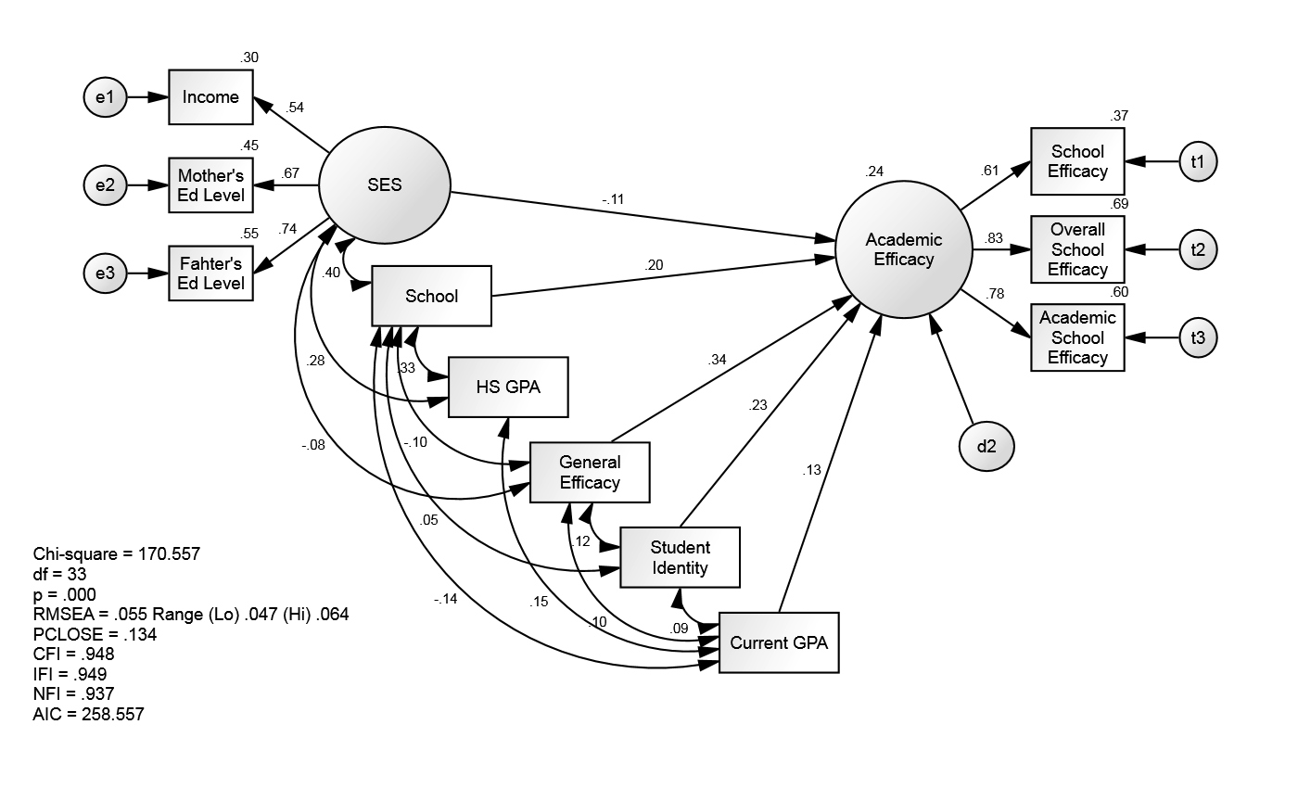
Figure 2. SEM of Academic Self-Efficacy Belief at Junior College
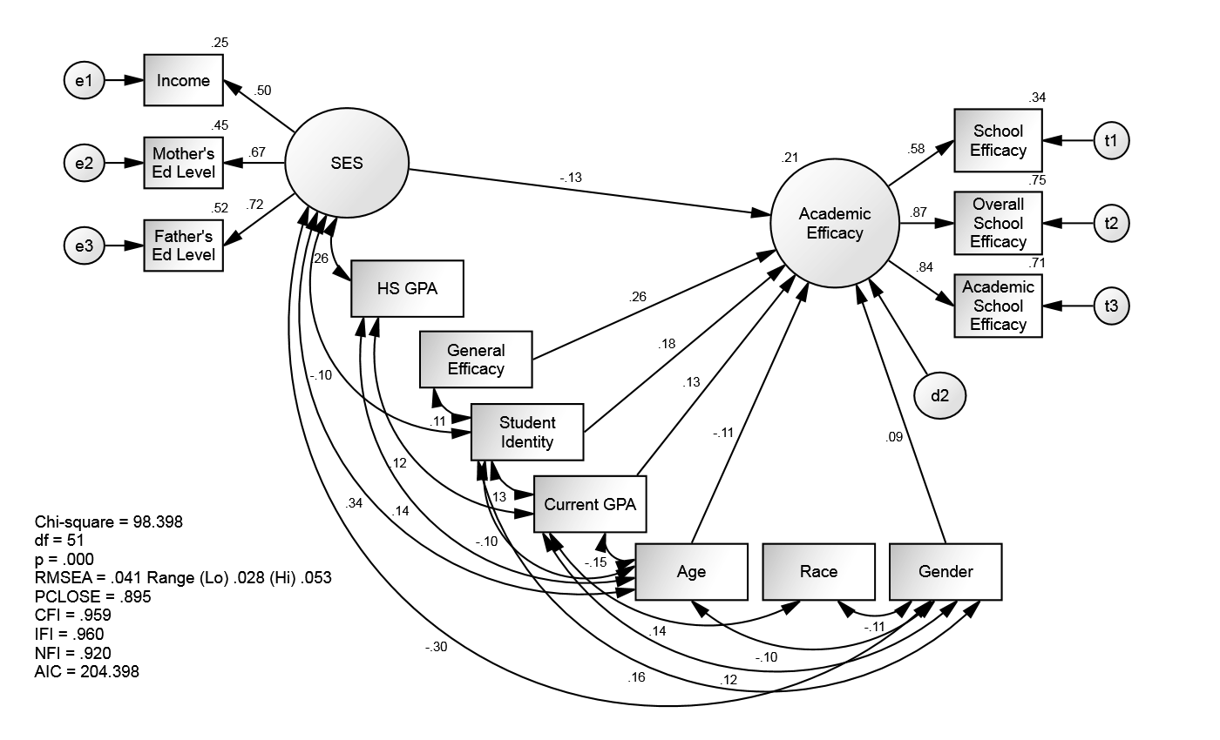
Figure 3. SEM of Academic Self-Efficacy Belief at Traditional University
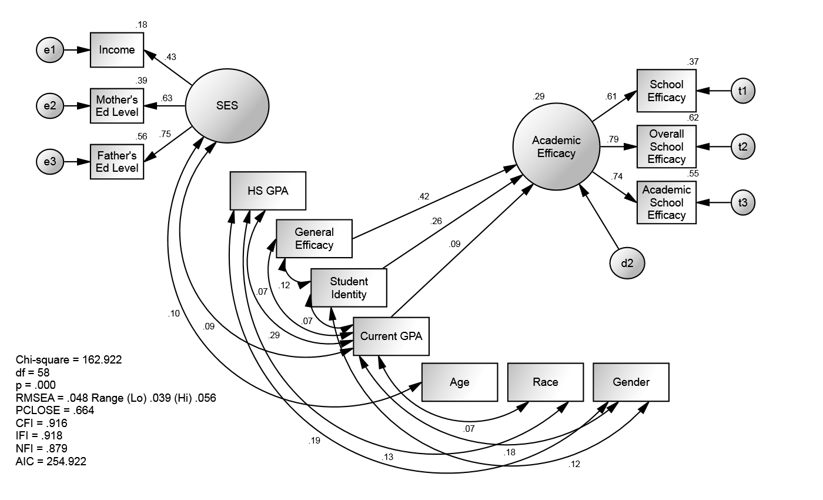

low of .48 and high of .065. Based on the large sample size, Chi-square was not a primary fit statistic.
Model 1 ran the combined sample with a dummy variable controlling for the higher education setting and Models 2 and 3 separated the sample populations based on the higher education setting to test the hypothesized effects within the different student populations.
Separate analyses shows that SES was only significant for junior college students (Model 2: SES β = -.133, p = .034). The significant effect in the combined sample was coming from the junior college respondents. SES was not a significant predictor of students’ perceptions of AE at the traditional university, and for junior college students there was a negative effect between SES and AE. As SES increased AE decreased. The difference in effect explains the seemingly contradictory results found in the correlation matrix and the smaller fit than expected for the combined sample.
Model fit for the traditional university also had a decrease in error and a slight change in overall fit with CFI .916, IFI .918, NFI .879, and RMSEA .048 (p = .664) CI low .39 high .56. The results of these separate HES analyses show that these models fit the data very well.
Looking at the higher education setting in Model 1, compared to students at the junior college traditional university students had higher AE (β = .201, p = .001). Not surprisingly global self-efficacy had the strongest effect on AE; as GE increased domain specific AE increased. This results is a noteworthy social psychological finding, uncovering a multidimensional aspect of the self-concept predicting a domain specific one.
The parameter estimates for the student identity in the combined (β = .233, p = .001), junior college (β = .176, p = .001), and traditional university (β = .259, p = .001) SEMs all had positive increases in AE. As the importance of the student identity increased AE increased. The effect was strongest at the university, but the level of significance did not diminish when
Table 3. Standardized FIML Estimates for SEM Models predicting Academic Self-Efficacy
 |  |  | Measurement Model |  | Model 1 – Full SEM |  | Model 2 – SEM for Junior College |  | Model 3 – SEM for Traditional University
 |  |  |  |  |  |  | β (Std. Error)
AE |  | SES |  |  | -.106** (.022) |  | -.133* (.034)
AE |  | HES |  |  | .201*** (.040)
AE |  | GE |  |  | .342*** (.024) |  | .258***(.034) |  | .420*** (.033)
AE |  | SiD |  |  | .233*** (.019) |  | .176*** (.027) |  | .259*** (.026)
AE |  | Curr GPA |  |  | .127*** (.016) |  | .126** (.023) |  | .090** (.020)
AE |  | Age |  |  |  |  | -.107* (.019)
AE |  | Gender |  |  |  |  | .092* (.054)
Age |  | SES |  |  |  |  | .338*** |  | .103*
GE |  | SES |  |  | -.082**
Curr GPA |  | SES |  |  |  |  |  |  | .092*
HES |  | SES |  |  | .395***
HS GPA |  | SES |  |  | .276*** |  | .264***
Race |  | SES |  |  |  |  |  |  | .126***
Gender |  | SES |  |  |  |  | -.303*** |  | .192***
SiD |  | SES |  |  |  |  | -.100*
SiD |  | HES |  |  | .053*
HS GPA |  | HES |  |  | .329***
HES |  | GE |  |  | -.100***
SiD |  | GE |  |  | .118*** |  | .113** |  | .119***
Curr GPA |  | GE |  |  | .095*** |  |  |  | .073*
Age |  | Curr GPA |  |  |  |  | -.152***
HES |  | Curr GPA |  |  | -.140***
SiD |  | Curr GPA |  |  | .088** |  | .130** |  | .072*
HS GPA |  | Curr GPA |  |  | .151*** |  | .122** |  | .293***
Race |  | Curr GPA |  |  |  |  | .137** |  | .075*
Gender |  | Curr GPA |  |  |  |  | .122** |  | .181***
Race |  | HS GPA |  |  |  |  |  |  | .126***
Age |  | HS GPA |  |  |  |  | .135**
Age |  | Gender |  |  |  |  | -.096*
Race |  | Gender |  |  |  |  | -.110**
Gender |  | SiD |  |  |  |  | .159*** |  | .116***
Age |  | SiD |  |  |  |  | -.096*
Obs1(AE) |  | AE | .608+ |  | .608+ |  | .583+ |  | .610+
Obs2(AE) |  | AE | .834*** |  | .834*** |  | .867*** |  | .787***
Obs3(AE) |  | AE | .777*** |  | .777*** |  | .844*** |  | .743***
Obs1(SES) |  | SES | .739+ |  | .738+ |  | .722+ |  | .750+
Obs2(SES) |  | SES | .670*** |  | .671*** |  | .669*** |  | .627***
Obs3(SES) |  | SES | .545*** |  | .544*** |  | .498*** |  | .425***
Chi-Square- χ² (df) |  |  | 170.341*** (32) |  | 170.557*** (33) |  | 98.398*** (51) |  | 162.922*** (58)
RMSEA (PCLOSE) |  |  | .056 (.098) |  | .055 (.134) |  | .041 (.895) |  | .048 (.664)
CFI |  |  | .948 |  | .948 |  | .959 |  | .916
IFI |  |  | .948 |  | .949 |  | .960 |  | .918
NFI |  |  | .937 |  | .937 |  | .920 |  | .879
AIC |  |  | 260.341 |  | 258.557 |  | 204.398 |  | 254.922
 |  |  | N = 1062 |  |  |  | n = 562 |  | n = 500
Legend: | AE = Academic Efficacy  Curr GPA = Current GPA  GE = Global Efficacy  HES = Higher Education Setting (Junior vs. Traditional) |  |  |  |  | HS GPA = High School GPA  Obs#(Construct) = Observed Item for Latent Variable  SES = Socioeconomic Status  SiD = Student Identity Centrality
 |  | + Fixed Parameter for Identification / * P ≤ .05 / ** P ≤ .01 / ***P ≤ .001

controlling for the institution. This outcome supports the positive relationship between self-efficacy and identity centrality (see Gecas & Schwalbe, 1983 for more).
Looking at additional control variables, high school GPA was not a significant predictor of current AE, but current GPA was. Too, when current GPA increased, so did AE. It is worth noting that the strength of the effect from current academic performance was similar in strength to SES, and for the junior college students the negative effect of SES was a stronger predictor (β = -.133, p = .026) than current GPA (β = .126, p = .006). Controls for age and gender were only significant at the junior college, and Race was not significant as a predictor for any of the SEMs. However, race was a significant covariate with other variables in the models. At the junior college younger students had lower self-efficacy beliefs than older students (β = -.107, p = .022) and women were more likely to report positive self-efficacy beliefs (β = .092, p = .046). SEM correlation results are discussed in the appendix.
Discussion
Findings demonstrate that SES was a significant predictor of the higher education program a student attended. Across each of the analyses, students from backgrounds with higher SES were more likely to attend a university as compared to a junior college.
Of primary interest was the test to determine if students at the junior college had equivalent academic self-efficacy beliefs compared to the traditional university students. Results of Table 1 found that despite having higher overall grade point averages, students at the junior college experienced lower academic self-efficacy beliefs compared to the traditional university peers.
It is impossible to know, based on the cross-sectional nature of these data if the lower self-efficacy beliefs were a product of the filtering produced by SES. Students at the junior college typically came from backgrounds of lower overall SES and research has found that these students experience significant challenges and internal conflict relating to an academic identity, when compared to students from higher SES backgrounds (Aronson & Inzlicht, 2004). Potentially, these findings uncover that AE is the product of a self-selection bias. However, rather than a confounding result this outcome was expected a priori. The hypotheses presented assume that SES is a predictor of the higher education setting a student attends.
SES background did not significantly impact a traditional university student’s belief about causal ability. It seems that in addition to being relatively insulated from the contemporary economic challenges facing higher education students from higher SES backgrounds are also insulated from negative psychological effects impacting AE.
Both academic settings brought students down a peg in terms of their global self-efficacy beliefs. However, when modeled separately the effect was stronger for the traditional university students. Previous research finds that university students are more likely than their junior college peers to have an empowered sense of entitlement (Baumeister et al., 2003; Greenberger et al., 2008); the rigor of college and related academic expectations along with a lowering of GPA between high school and college challenges this entitled self-belief. However, in spite of experiencing a dose of “humble pie” traditional university students reported higher AE when compared to their junior college peers (see Reinhardt, 2012 for more on this point).
The student role-identity was more central for the university students’ self-concept. For junior college students structural inequality is recursive with the self-processes involved. The cycle of inequality that students from lower SES face socializes these students to expect less of themselves (Scott, 2003). In other words, lower SES students hedge their bets and psychologically compartmentalize self-meanings according to the structural conditions of inequality that they face (Festinger, 1964; Osborne, 1995). For example, a student might ask herself, “Why should I place the role-identity of student in a central place of importance for my self-concept?” Thereby protecting herself from negative feedback related to this identity.
The analysis also suggests that a student’s current GPA predicts the current sense of academic self-efficacy, but previous GPA does not. Pajares (1996) notes that the linkage between a student’s previous performance and current performance is strongly mediated by self-efficacy beliefs (see also LaBelle, Martin, & Weber, 2013). When it comes to a student’s feelings of empowerment as fostered by the academic environment, previous accomplishments influence current performance insofar as current beliefs about agentive ability support performance. What matters is the “here and now.” These findings support the mediating link identified by Pajares (see also Pearlin & Schooler, 1978). This linkage is essentially the heart of this study. Recognizing that self-efficacy plays a key role influencing future life opportunity I set out to test potential differences in self-efficacy beliefs between junior college and traditional university students. These findings indicate that there is an inequality of self-efficacy beliefs between students in these two institutions of higher education. Past performances can be minimized by current self-efficacy beliefs. Finding higher average grades and lower self-efficacy beliefs among junior college students indicates that the inequalities found in society are reproduced as structural inequality between these institutions of higher education.
Limitations and Concluding Remarks
The major limitation of this study has already been suggested, data comes from a large cross-sectional study, limiting generalizability. Future research working on higher education and self-efficacy beliefs would be strengthened by a longitudinal design using a panel study to track students from primary education, through college, and into life beyond schooling. A longitudinal design would allow future researchers to address the possibility of a self-selection bias. The hope is that the present study acts as motivation for continued research into the impact institutions of higher education have on the social psychological processes impacting student outcomes.
While considerable care was taken to get representative samples of students, the idiosyncrasies of each institution must be taken into account. The Midwestern setting and the types of students who attended both institutions (disproportionately white, relatively privileged and conservative) likely influenced the results to some degree. Subsequent study would benefit from a larger and more diverse pool of students and institutional settings. Greater generalizability would provide more robust conclusions about how structural inequality in higher education permits as well as reproduces the social psychological inequalities identified in this study.

References
Ajzen, I. (1991). The theory of planned behavior. Organizational behavior and human decision processes, 50(2), 179-211.
Alicia, C. D., John, J. C., & Tatiana, M. (2008). Transfer Access from Community Colleges and the Distribution of Elite Higher Education. The Journal of Higher Education, 79(4), 442-472.
Aronson, J., Blanton, H., & Cooper, J. (1995). From Dissonance to Disidentification: Selectivity in the Self-Affirmation Process. Journal of Personality and Social Psychology, 68(6), 986-996.
Aronson, J., & Inzlicht, M. (2004). The Ups and Downs of Attributional Ambiguity: Stereotype Vulnerability and the Academic Self-Knowledge of African American College Students. Psychological Science, 15(12), 829-836.
Ball, S. J., Davies, J., David, M., & Reay, D. (2002). 'Classification' and 'Judgement': Social Class and the 'Cognitive Structures' of Choice of Higher Education. British Journal of Sociology of Education, 23(1), 51-72.
Bandura, A. (1986). Social foundations of thought and action : a social cognitive theory. Englewood Cliffs, N.J.: Prentice-Hall.
Bandura, A., Barbaranelli, C., Caprara, G. V., & Pastorelli, C. (2001). Self-Efficacy Beliefs as Shapers of Children's Aspirations and Career Trajectories. Child Development, 72(1), 187-206.
Baumeister, R. F., Campbell, J. D., Krueger, J. I., & Vohs, K. D. (2003). Does High Self-Esteem Cause Better Performance, Interpersonal Success, Happiness, or Healthier Lifestyles? Psychological Science in the Public Interest, 4(1), 1-44.
Britner, S. L., & Pajares, F. (2006). Sources of science self-efficacy beliefs of middle school students. Journal of Research in Science Teaching, 43(5), 485-499.
Caprara, G. V., Vecchione, M., Alessandri, G., Gerbino, M., & Barbaranelli, C. (2011). The Contribution of Personality Traits and Self-Efficacy Beliefs to Academic Achievement: a Longitudinal Study. British Journal of Educational Psychology, 81(1), 78-96.
Choi, N. (2005). Self-efficacy and self-concept as predictors of college students' academic performance. Psychology in the Schools, 42(2), 197-205.
Cohen, A. M., & Brawer, F. B. (2003). The American Community College: Wiley.
Festinger, L. (1964). Conflict, decision, and dissonance. Stanford, Calif.,: Stanford University Press.
Frucot, V. G., & Cook, G. L. (1994). Further Research on the Accuracy of Students' Self-Reported Grade Point Averages, SAT Scores, and Course Grades. Perceptual and motor Skills, 79, 743-746.
Gecas, V. (1989). The Social Psychology of Self-Efficacy. Annual Review of Sociology, 15, 291-316.
Gecas, V., & Schwalbe, M. L. (1983). Beyond the Looking-Glass Self: Social Structure and Efficacy-Based Self-Esteem. Social Psychology Quarterly, 46(2), 77-88.
Goldberg, L. R., Johnson, J. A., Eber, H. W., Hogan, R., Ashton, M. C., Cloninger, C. R., & Gough, H. C. (2014). International Personality Item Pool: A Scientific Collaboratory for the Development of Advanced Measures of Personality Traits and Other Individual Differences (Internet Web Site). http://ipip.ori.org/
Greenberger, E., Lessard, J., Chen, C., & Farruggia, S. P. (2008). Self-Entitled College Students: Contributions of Personality, Parenting, and Motivational Factors. Journal of Youth and Adolescence, 37(10), 1193-1204.
LaBelle, S., Martin, M. M., & Weber, K. (2013). Instructional Dissent in the College Classroom: Using the Instructional Beliefs Model as a Framework. Communication Education, 1-22.
Majer, John M. 2009. "Self-efficacy and Academic Success among Ethnically Diverse First-generation Community College Students." Journal of Diversity in Higher Education 2(4):243-50.
Mattern, K. D., & Shaw, E. J. (2010). A Look Beyond Cognitive Predictors of Academic Success: Understanding the Relationship Between Academic Self-Beliefs and Outcomes. Journal of College Student Development, 51(6), 665-678.
Mitchell, J. C., Eagan, M. K., Monica, H. L., & Sylvia, H. (2011). Considering the Impact of Racial Stigmas and Science Identity: Persistence Among Biomedical and Behavioral Science Aspirants. The Journal of Higher Education, 82(5), 564-596.
Morris, R. C. (2012). The Relative Influence of Values and Identities on Academic Dishonesty: A Quantitative Analysis. Current Research in Social Psychology, 19(2), 1-20.
Morris, R. C. 2013. Identity Salience and Identity Importance in Identity Theory. Current Research in Social Psychology, 21(8): 23-36
Osborne, J. W. (1995). Academics, Self-Esteem, and Race: A Look at the Underlying Assumptions of the Disidentification Hypothesis. Personality and Social Psychology Bulletin, 21(5), 449-455.
Pajares, F. (1996). Self-Efficacy Beliefs in Academic Settings. Review of Educational Research, 66(4), 543-578.
Pearlin, L. I., & Schooler, C. (1978). The structure of coping. Journal of Health and Social Behaviour, 19, 2-21.
Putwain, D., Sander, P., & Larkin, D. (2012). Academic self-efficacy in study-related skills and behaviours: relations with learning-related emotions and academic success. British Journal of Educational Psychology, n/a-n/a.
Reay, D., David, M. E., & Ball, S. J. (2005). Degrees of Choice: Social Class, Race and Gender in Higher Education: Stoke-on-Trent, UK ; Sterling, VA: Trentham.
Reinhardt, J. (2012). Conceptualizing Academic Entitlement: What are we Measuring? , Paper 41, University of Windsor.
Royce, E. C. (2009). Poverty and Power: The Problem of Structural Inequality: Rowman & Littlefield Publishers.
Scott, L. D., Jr. (2003). The Relation of Racial Identity and Racial Socialization to Coping with Discrimination among African American Adolescents. Journal of Black Studies, 33(4), 520-538.
Stryker, S., & Serpe, R. T. (1994). Identity Salience and Psychological Centrality: Equivalent, Overlapping, or Complementary Concepts? Social Psychology Quarterly, 57(1), 16-35.
Townsend, B. K., McNerny, N., & Arnold, A. (1993). Will This Community College Transfer Student Succeed? Factors Affecting Transfer Student Performance. Community College Journal of Research and Practice, 17(5), 433-433.
Turner, R. H. (1978). The Role and the Person. American Journal of Sociology, 84(1), 1-23.
van Dinther, M., Dochy, F., & Segers, M. (2011). Factors affecting students’ self-efficacy in higher education. Educational Research Review, 6(2), 95-108.

Appendix: Additional Methodolocial and Analysis Details

The dependent variable, Academic Self-Efficacy (AE), came from three items. The first two measures are Likert items ranging from strongly agree to strongly disagree with a sixth category for don't know and a seventh for refuse to answer.
Item 1: Based on just my educational experience at the institution where I am currently enrolled I expect to be able to do just about anything I really set my mind to.
Item 2: Based on my overall experience at the institution where I am currently enrolled I expect to be able to do just about anything I really set my mind to.
Item 3: To what extent would you say that the current institution at which you are enrolled has prepared you for success after graduation (item 3 is also a Likert item ranging from a great deal to poorly with a sixth category for don't know and a seventh for refuse to answer – all emphases in original items)?
Following the work of Pajares, the analysis focused on both domain specific (AE) and global self-efficacy. The original plan for measuring global self-efficacy (GE) was to create a scaled measure similar to AE. Five Likert items from the International Personality Item Pool (IPIP) were analyzed for GE (Goldberg et al., 2014). However, during dimension reduction the five items for GE did not hang together. Loadings and measures of Cronbach’s alpha get reported in the Appendix Table. The GE scale has since been replaced by the psychometrician's who oversee the IPIP in favor of new scales of GE. For this reason, the measure of GE used in this study came from a single item: I can do just about anything I really set my mind to.
Measurement of academic performance came from self-reported grade point average (GPA). Respondents were asked to report both High School and current GPA (for a critique of this methodology see Frucot & Cook, 1994). The scale consisted of 8 categories (including don't know) beginning with < 1.0, moving up in .5 increments and topping out at 3.5 – 4.0.
The measure of socioeconomic status (SES) came from three items. Item one asked respondents to select the category containing the income for their "primary place of residence (permanent address)" on a Likert scale. The second item asked respondents to identify the level of education their mother completed, and the third item asked respondents to identify the level of education completed by their father. Six categorical options were provided beginning with (1) Less than High School Diploma up to (6) PhD or Professional Degree. Factor loadings and Cronbach’s alpha for SES are also reported in Appendix Table.
Appendix Table. Variables used for Analysis including Descriptive Statistics and Factor Scale Creation
 | AE |  | Age |  | GE |  |  |  |  | HES |  | Race |  | SES |  | Gender |  | SiD
Applicable Factor Loadings
 | Factor  1 |  |  |  | Factor  1 |  | Factor  2 |  |  |  |  |  |  | Factor  1
Item 1 | .600 |  |  |  | .492 |  | .218 |  |  |  |  |  |  | .757
Item 2 | .818 |  |  |  | .599 |  |  |  |  |  |  |  |  | .504
Item 3 | .784 |  |  |  | .504 |  | .300 |  |  |  |  |  |  | .677
Item 4 |  |  |  |  |  |  | .653
Item 5 |  |  |  |  | .341 |  | .423
KMO= | .676 |  |  |  |  | .656 |  |  |  |  |  |  |  | .641
Alpha= | .772 |  |  |  |  | .545 |  |  |  |  |  |  |  | .656
Descriptive Statistics
Mean | 0^{ASY} |  | 3.08 |  | GE results of item  #4: | 2.558 |  |  |  | .587 |  | .778 |  | 0^{ASY} |  | .533 |  | 4.076
SD | 1 |  | 1.18 |  | GE results of item  #4: | 1.258 |  |  |  | .492 |  | .416 |  | 1.181 |  | .499 |  | .923
Min | -3.549 |  | 1 |  | GE results of item  #4: | 1 |  |  |  | 0 |  | 0 |  | -2.757 |  | 0 |  | 1
Max | 1.427 |  | 5 |  | GE results of item  #4: | 5 |  |  |  | 1 |  | 1 |  | 2.693 |  | 1 |  | 5
Variable Legend:  AE = Academic Efficacy  GE = Global Efficacy  HES = Higher Education Setting  SES = Socioeconomic Status  SiD = Student Identity Centrality |  |  |  |  |  |  |  | Statistical Legend:  Alpha = Cronbach’s Alpha  ^{ASY} = Asymptotically Correct  KMO = Kaiser-Meyer-Olkin Measure of Sampling Adequacy  SD = Standard Deviation

Additional predictors included: the measure of higher education setting (HES) a binary variable 0 = junior college 1 = traditional university. The measure of psychological centrality for the student role-identity (SiD) which asked, "Thinking only of your role as a student would you agree or disagree with the following statement: being a student is important to the way I think about myself (options again ranged from strongly agree to strongly disagree with a sixth and seventh categories for don't know and refuse to answer). Gender was measured as a binary variable 0 = Male 1 = Female. Age was recorded by asking respondents to report the year they were born and then collapsed into five categories, as the numeric value of the category goes up (more recent birth year) age decreases. Race was collapsed to a binary variable 0 = Other Race 1 = White. Dummying of Race was necessary due to empty cells.
SEM Correlation Findings
The SEM analysis concluded with a review of the covariates. The negative relationship between GE and SES found in the bi-variate correlation matrix (β = -.071, p = .05) was only present for the combined sample (SEM correlation = -.082, p = .01). The relationship was not significant when the samples were controlled by the higher education setting. The correlation between GE and SES in the SEM for the traditional University was -.056 (p = .197), and for the junior college the correlation was -.037 (p = .432). This was the only relationship present in the full sample of Model 1 to disappear from both Models 2 and 3 when controlling for the higher education setting. As noted before, the combined strength from both student populations was necessary to produce a significant correlation. Consistent with the previous results as SES went up AE went down; more on this point in the discussion.
The relationship between the higher education setting and SES produced the strongest correlation in the SEMs (Model 1: .395, p = .001). SES mattered when it came to a student’s likelihood of attending a junior college versus a traditional university. As SES increased so did traditional university attendance.

This study focuses on role-identities, but acknowledges the importance of self-efficacy beliefs for other modality of identity.
I explicitly reject a simple binary opposition between structural and agentive determinants, as human beings are understood to be both subject to and producers of the environment in which they interact.
Undergraduate enrolment at the large university is approximately 30,000 with graduate enrollment 10,000. Junior college enrollment at this location is approximately 7,500.
Instructors who donated a class session began their class with an introduction, turned the time over, and then departed. At the beginning of each class session a recruitment script was read including voluntary participation and risk disclosures. 31 classes at the junior college and 18 at the traditional university are represented in these data. No student at either institution elected not to participate.
Full details of these data are available upon request.

